

**Supervisor**

### Who is the supervisor:

The main supervisor is chosen to track the whole process of the project including selection of project members, leading the project to succeed and others. In addition, they select other supervisors and advisors for the project. They are responsible for the completion of the project and should be aware of the deadlines.

### What does supervisor need after logging in?

* Complete your profile
* Choose your Experience Badges
* Go through the projects and find the ones that you find interesting
* Increase in your credit
* Apply for the projects
* Sign the contract for the main supervisor
* Create your own team
* Set the meeting time, Communication link, and Language
* Specify tasks for the members within the project

### How can supervisor define a new project?

* Go to suggest a project
* Fill the information
* Increase in your credit if the project is funded
* Send an RFP, Proposal
* Sign the contract

### What does supervisor need after logging in:

### **Complete your profile**

Everybody can register in the site through “Join Us” bottom, as follows:





Then, if you are signing up as an individual

person, please select “**Individual”** and fill

out the form as follows:

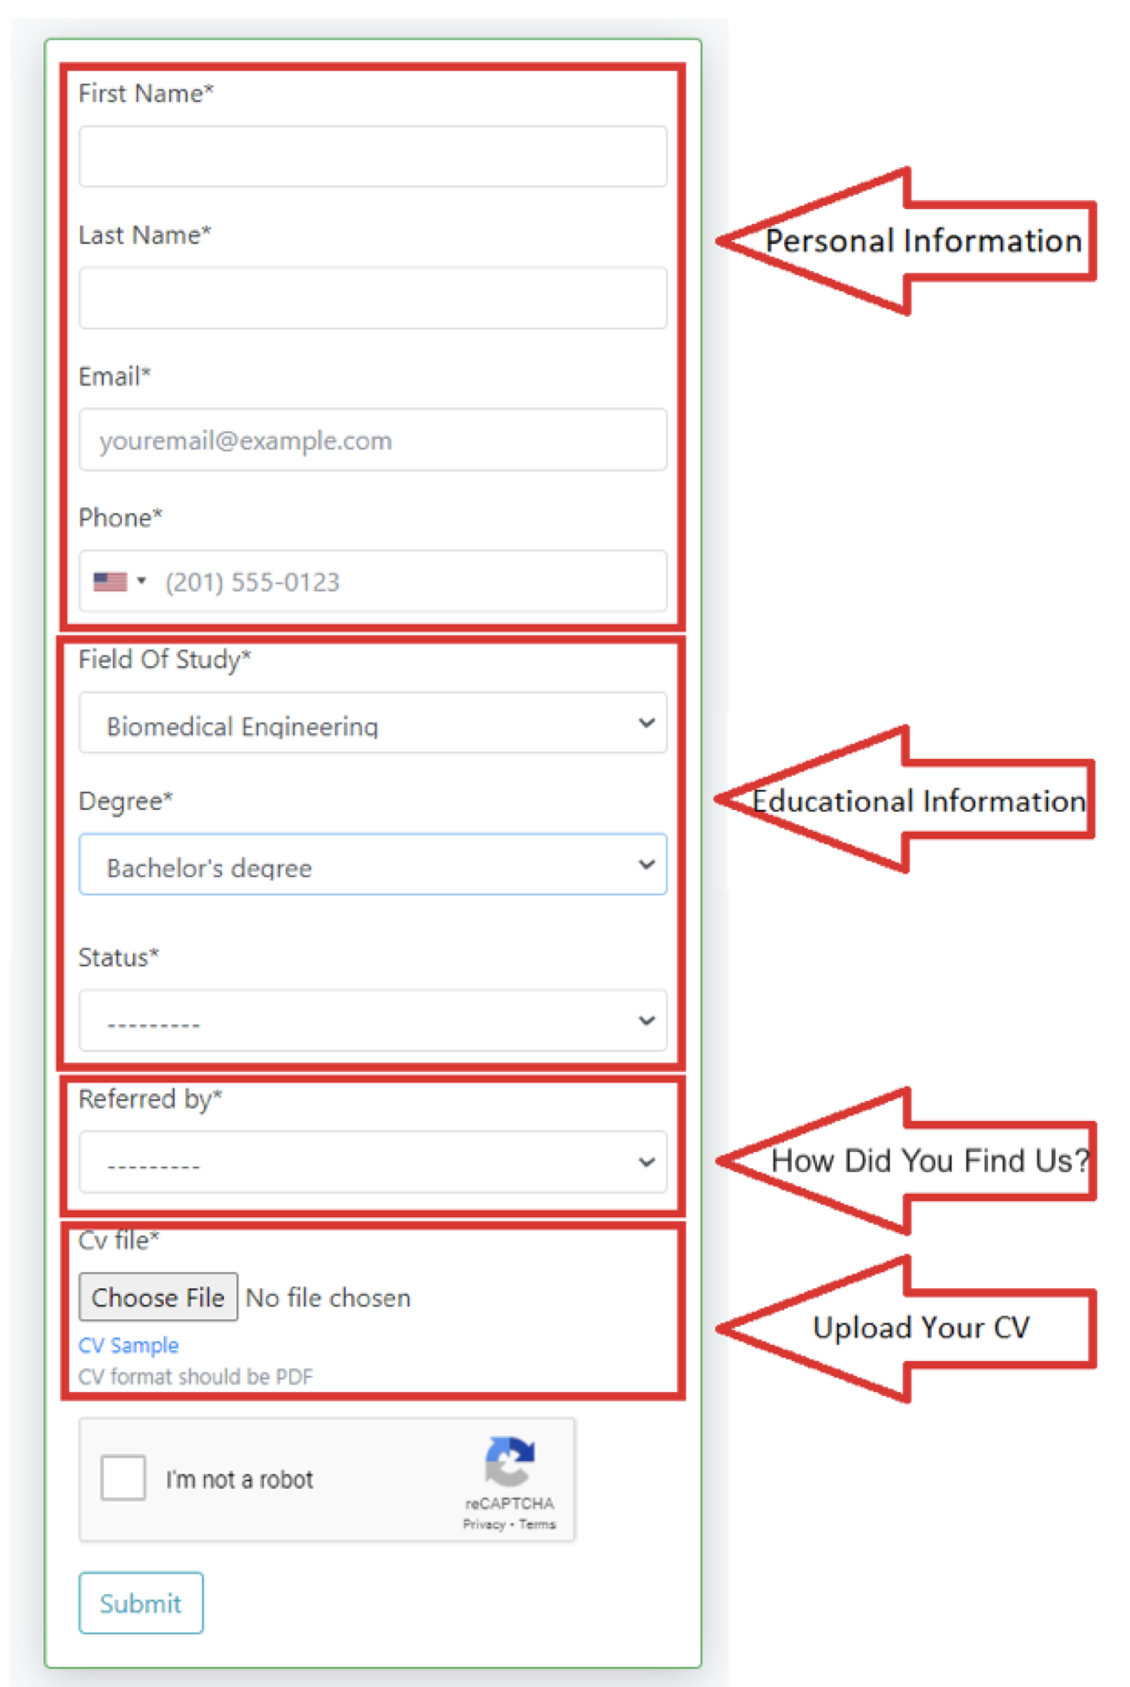

If you are signing up as a company, please

select “**Company”** and complete the form as

follows:

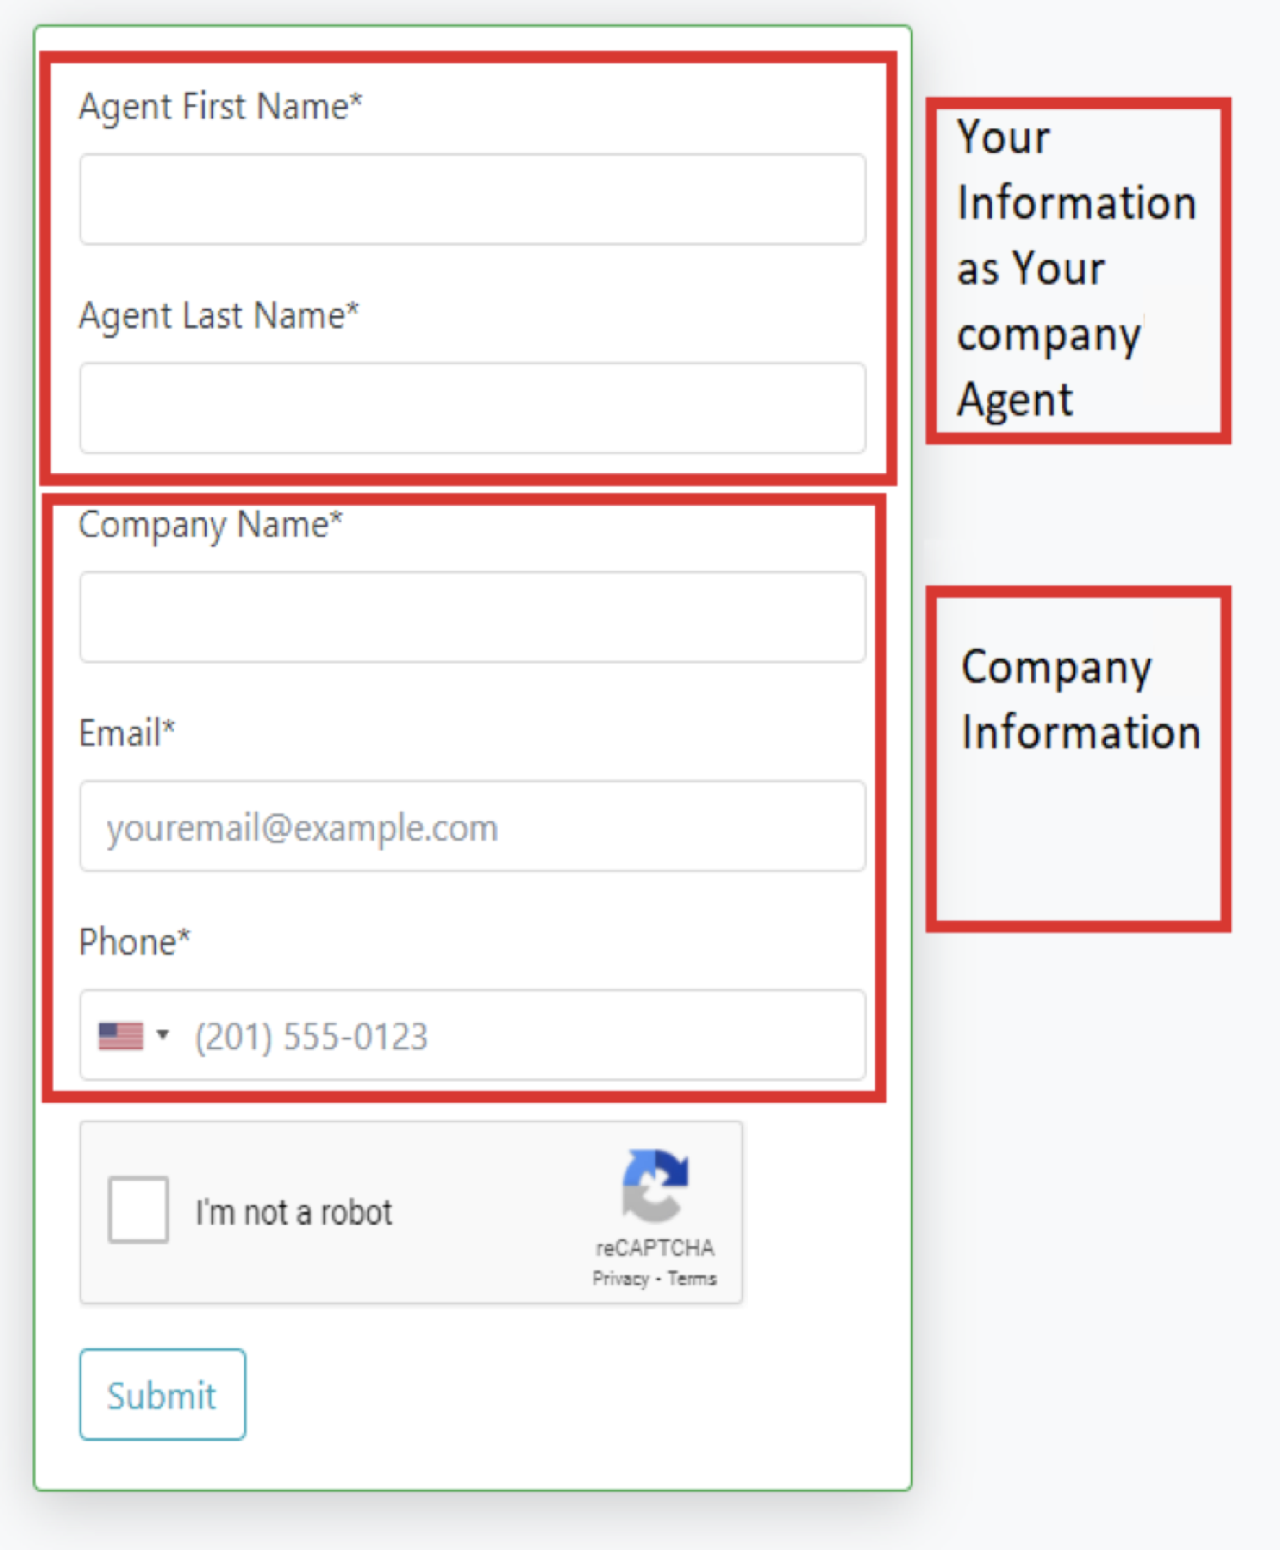

If you are logging in your profile for the first time, you are requested to provide your profile with necessary information as follows. In addition, everybody has access to their profile via “Dashboard/Profile”.

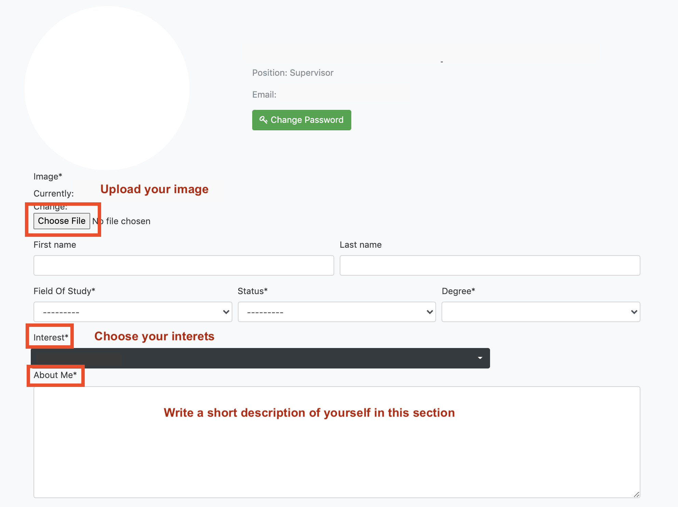

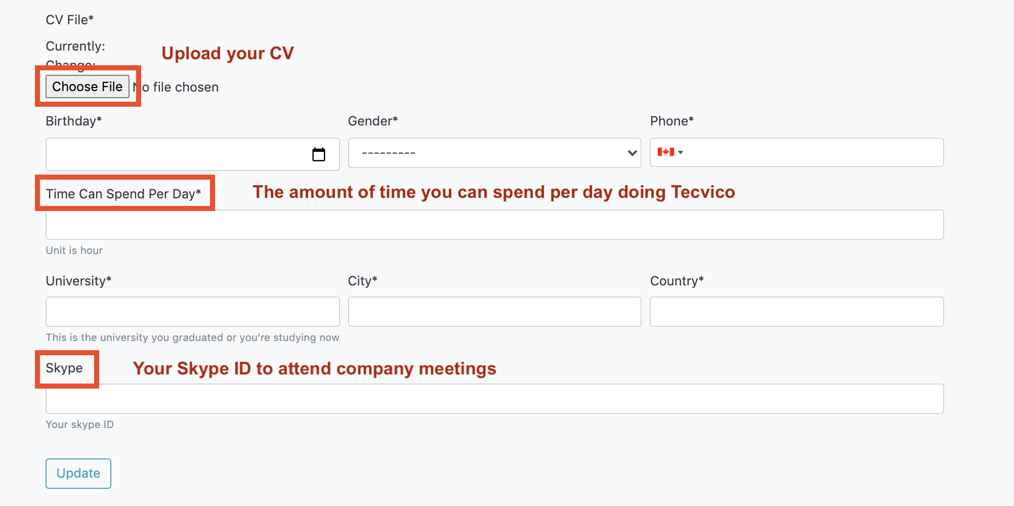

### **Choose your Experience Badges**

In addition, you are requested to determine your badges in your “Dashboard” as follows.

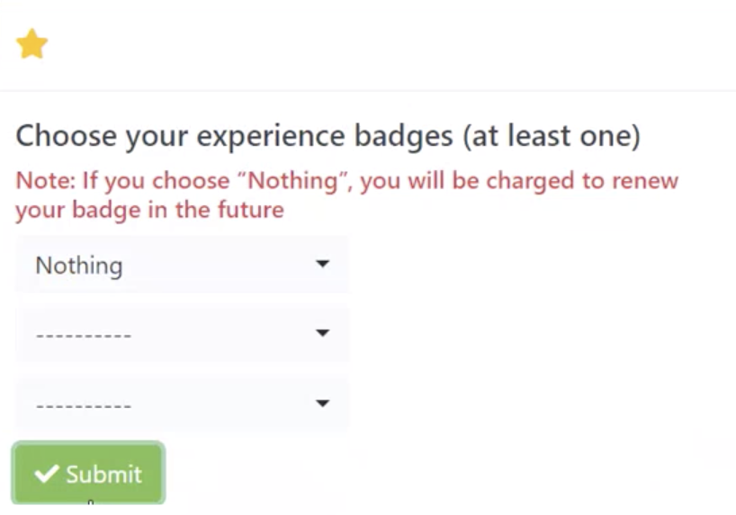

If you want to apply for Research projects, you must specify your experience Badges. The supervisor will consider your application to participate in the project based on your selected badges and how well it aligns with the required skills in the project. You choose these badges according to the skills you have.

In addition, after the project is done, supervisor will give new badges to you or update badge scores.

Moreover, if you would like to add some badge to your profile, you must request. The company will charge you and then determining an interviewer to specify your badge. The meeting will be as online.

Based on your efficiency, the supervisor will add or deduct in score of your badge. In fact, this action causes an automatic system to tune badges. Badges also play a crucial role in participation into Competition and Industry projects.

### 

### **Go through the projects and find the ones that you find interesting**

After completing your profile, from the “Projects” section in your “Dashboard”, you can see the types of projects available in the company and select the projects that are closest to your research field and interests as follow:

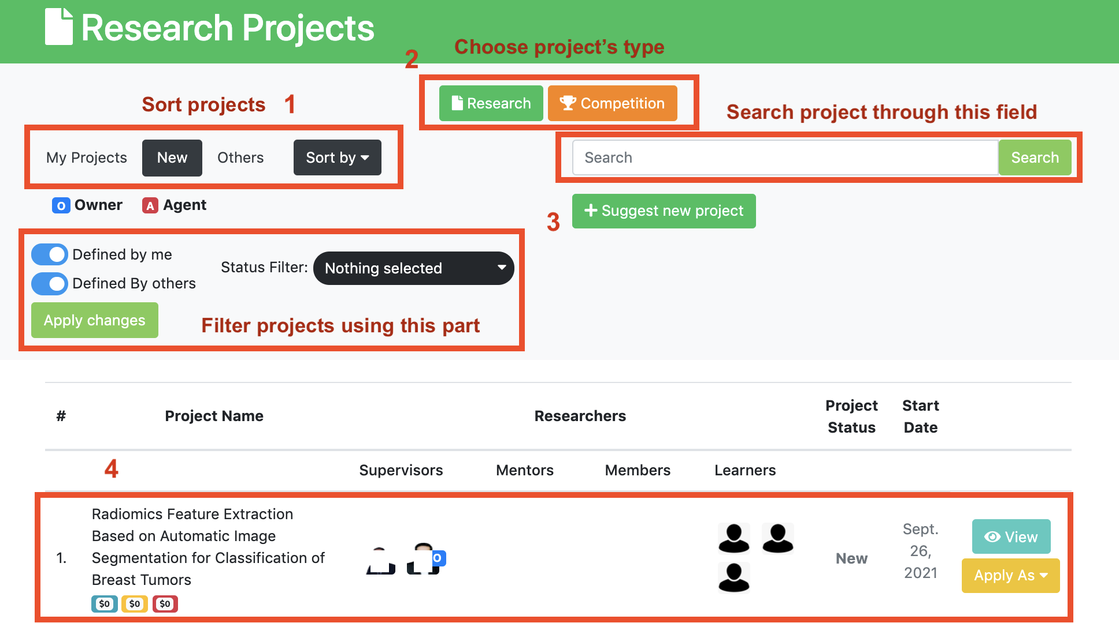

[1] -> This page has three tabs: My Projects, New and Others.

In the “New” tab, you can see all the projects that are new and haven’t started yet.

[2] -> You can also select a project type to see projects in each field. (Research, Industry, Competition)

[3] -> At the top of this page, you can search for a project or filter projects using filters.

[4] -> In the end, you can find the project you want among the projects and apply for it.

### **Increase in your credit**

Balance is the amount of currency you have in your account.

You can see your balance in your “Dashboard”, at the top right of the page.

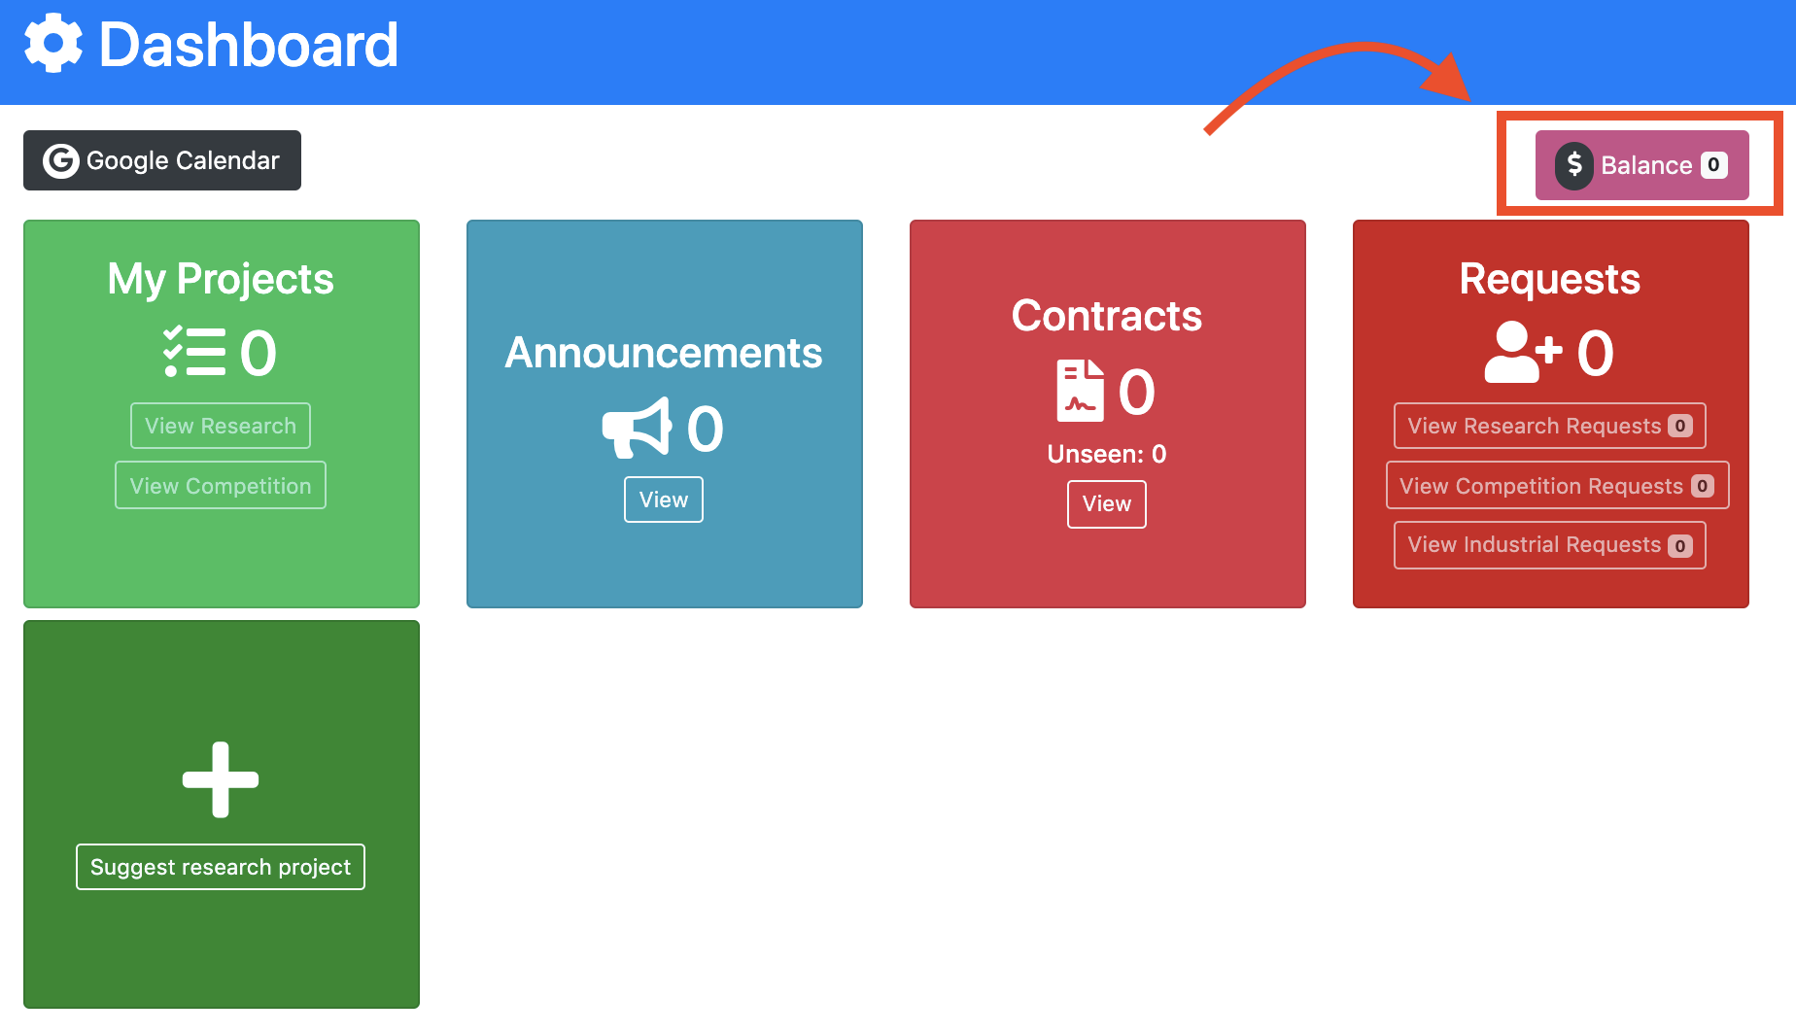

You can increase in your balance by clicking on it and adding the amount that you need to it. You may be redirected to another page that you first enter the amount, choose one of the payment methods (Stripe/Paypal), and then do the checkout as follows.

**Note**: Everybody is able to apply for a specific project if they have an enough balance.

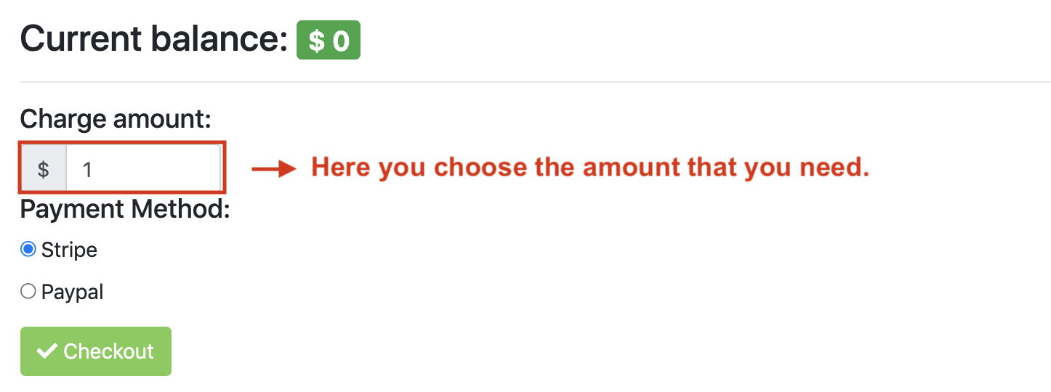

### **Apply for the projects**

If you would like to participate in the project, just click the “Apply” button of the project you want and choose your role you want to be in the project. The result of your request will be announced via Email or a notification in your profile via the main supervisor.

You can apply for projects as your role or the roles that fall under your category. For example, if your role is supervisor, you can apply for projects as Main Supervisor, Supervisor, Mentor, Member or Learner. If you are a mentor, you can apply for just Mentor, Member or Learner and so on.

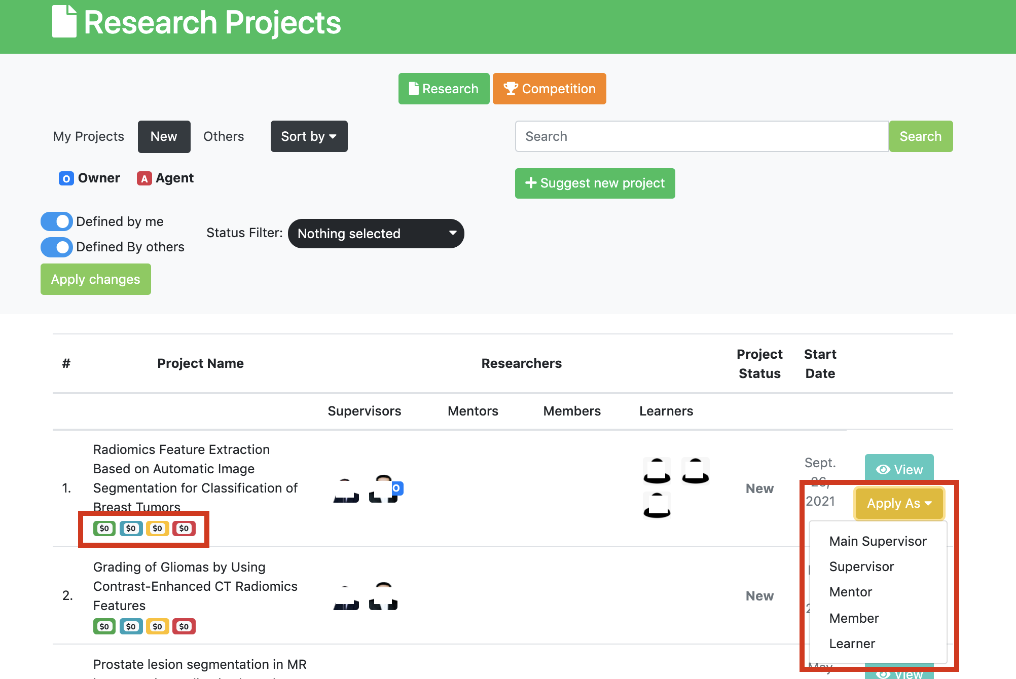

# **Responsibility Fee**



The 4 colored boxes under the name of each project are the amount that is required to enter the project, which is called “Responsibility Fee” and each role has different responsibility fee. Amount of responsibility fee for each role directly depends on importance of position in project. The green box is for the Supervisors, the blue box is for Mentors, the yellow box is for Members and the red box is for Learners.

When you apply for a project, the responsibility fee will temporarily be deducted from your wallet and blocked. if your application is approved by supervisor, the responsibility fee will permanently be deducted from your balance. In contrast, if your application is rejected, the responsibility fee will surely return to your wallet. If you don’t have enough balance which is required to apply for a project, you are not able to apply for it. Thus, you can increase in your balance as much as you need and then apply for the project.

Moreover, if you want to apply as Main Supervisor, you must submit a project proposal with your application. Director team in each section (Industry and research) approve your proposal will finally accept or reject the proposals. Each proposal will be evaluated by at least 2 referees.

Director team consists of Research Director and Research Expert. They are responsible for identifying the main supervisor of each project by evaluating the submitted proposals.

### **Sign the contract for the main supervisor**

If your application has been approved by Director team, a contract is sent to you and is accessible through your “Contracts” section in Dashboard. The main supervisor must read and sign the contract. The supervisor must then upload the signed contract. Next that, the director team will check and then s/he will be accepted as main supervisor. The below figure show where the supervisor can find the contract.

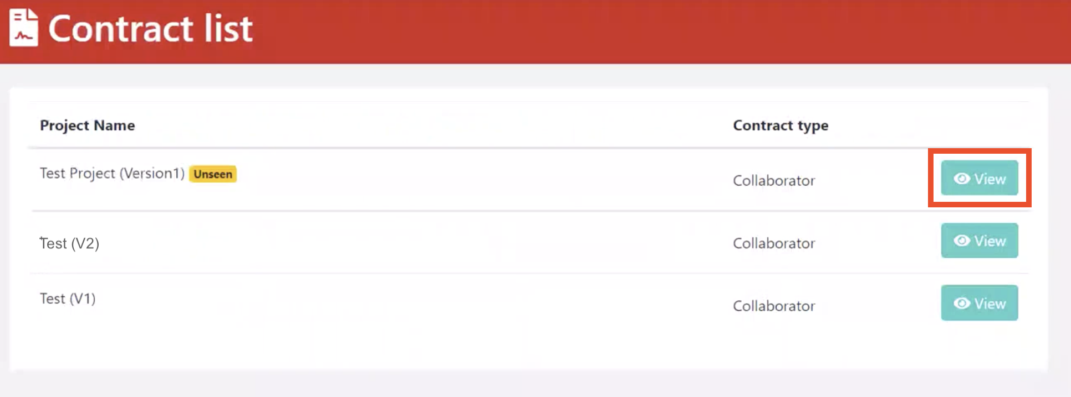

For other applicants including supervisors, mentors, members, and learner, the main supervisor will observe the contract on behalf of the company.

After clicking on “View”, you will enter the below page. From “View Contract” you should open the contract and then reading, downloading as PDF, and signing. In the end, you must upload the signed contract and then press Submit button as follows.

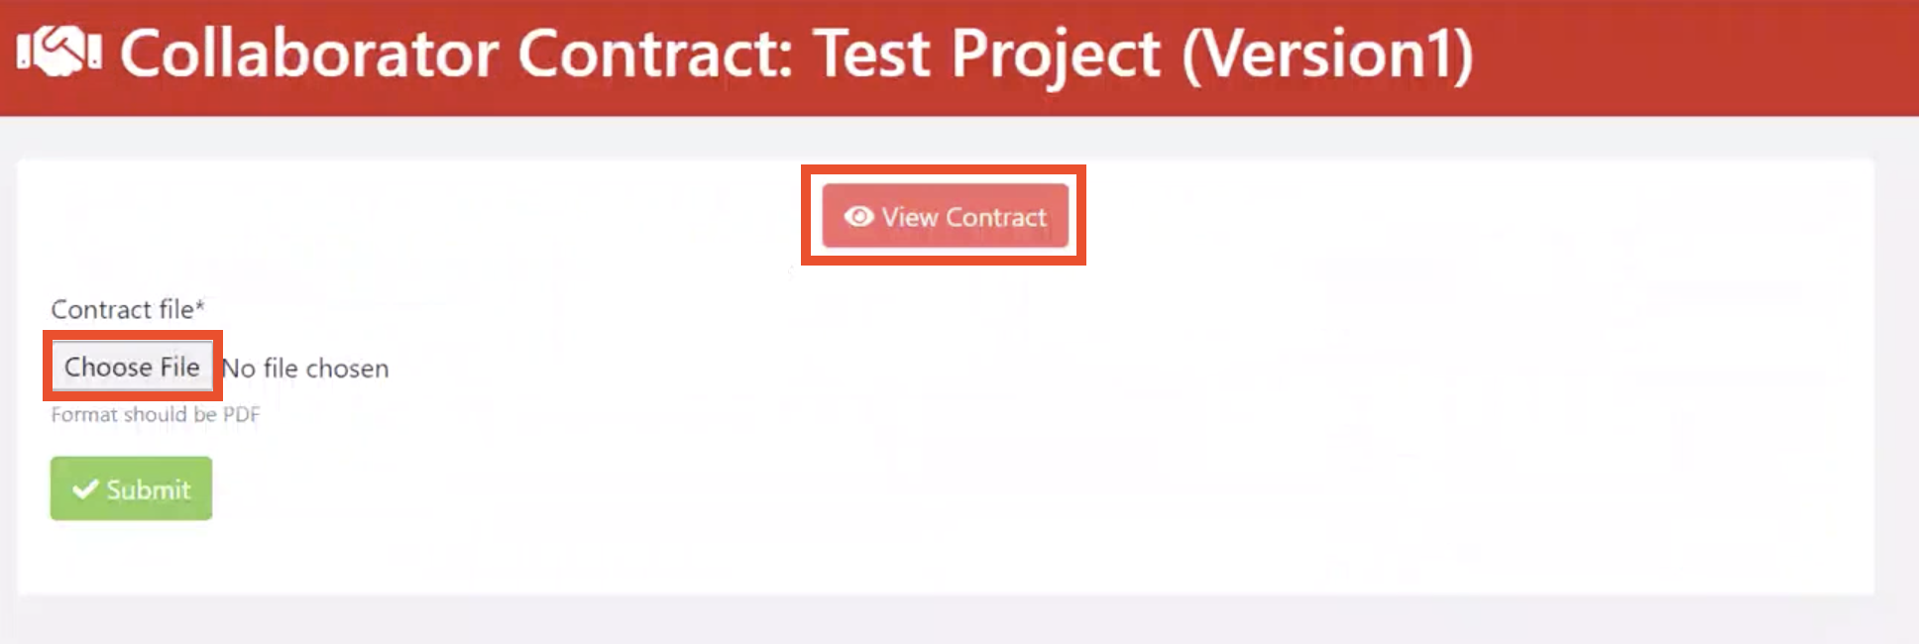

After that, you can see your submitted contract as follows.

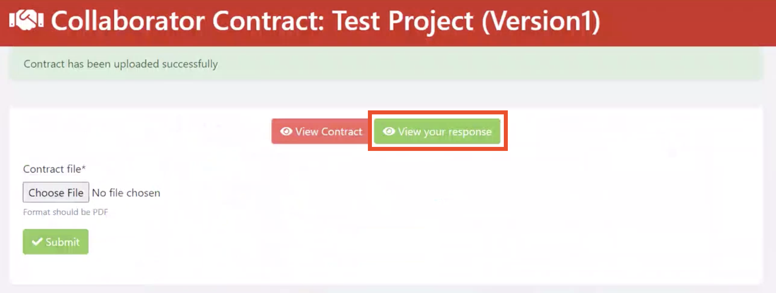

### **Create your own team**

# Now it’s time to form a team.

# In research section, after evaluation of proposal via reviewers and final decision making via director team, status of project would be changed to new project. From that time, everybody can see the project in their profile, and they can then apply for it. While, in industry section, status of project may be changed to new when director team decide the project is doable. For competition, the company acts similar to research section.

From the “Requests” section in your Dashboard, you can manage these requests and accept the members you want to collaborate with on the project as follows.

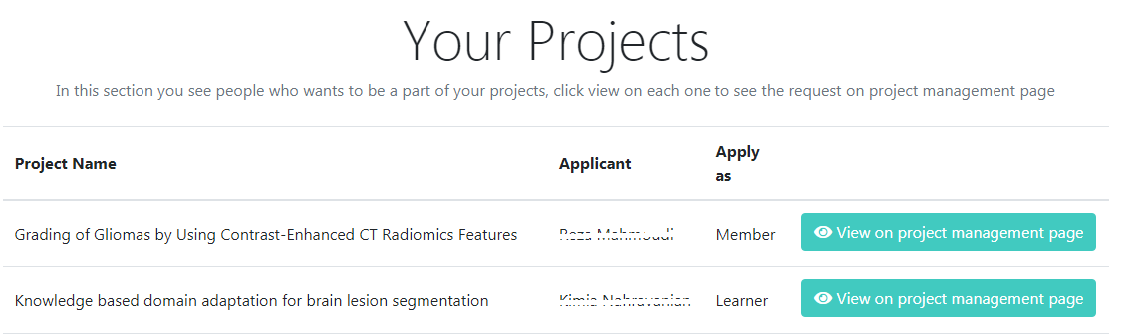

By clicking on , the manage tab of your project will open, you can then accept or reject the request in the pending section.

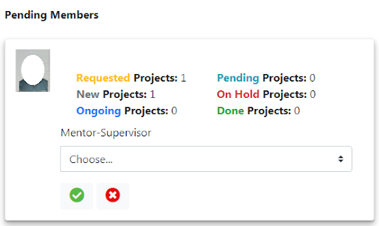

If you would like to accept the request, you must choose your name as the Main Supervisor of that person for the project.

On this page you can also send requests to supervisors/mentors/members you want to participate in the project.

By selecting the person's name, a request is sent to her/him.

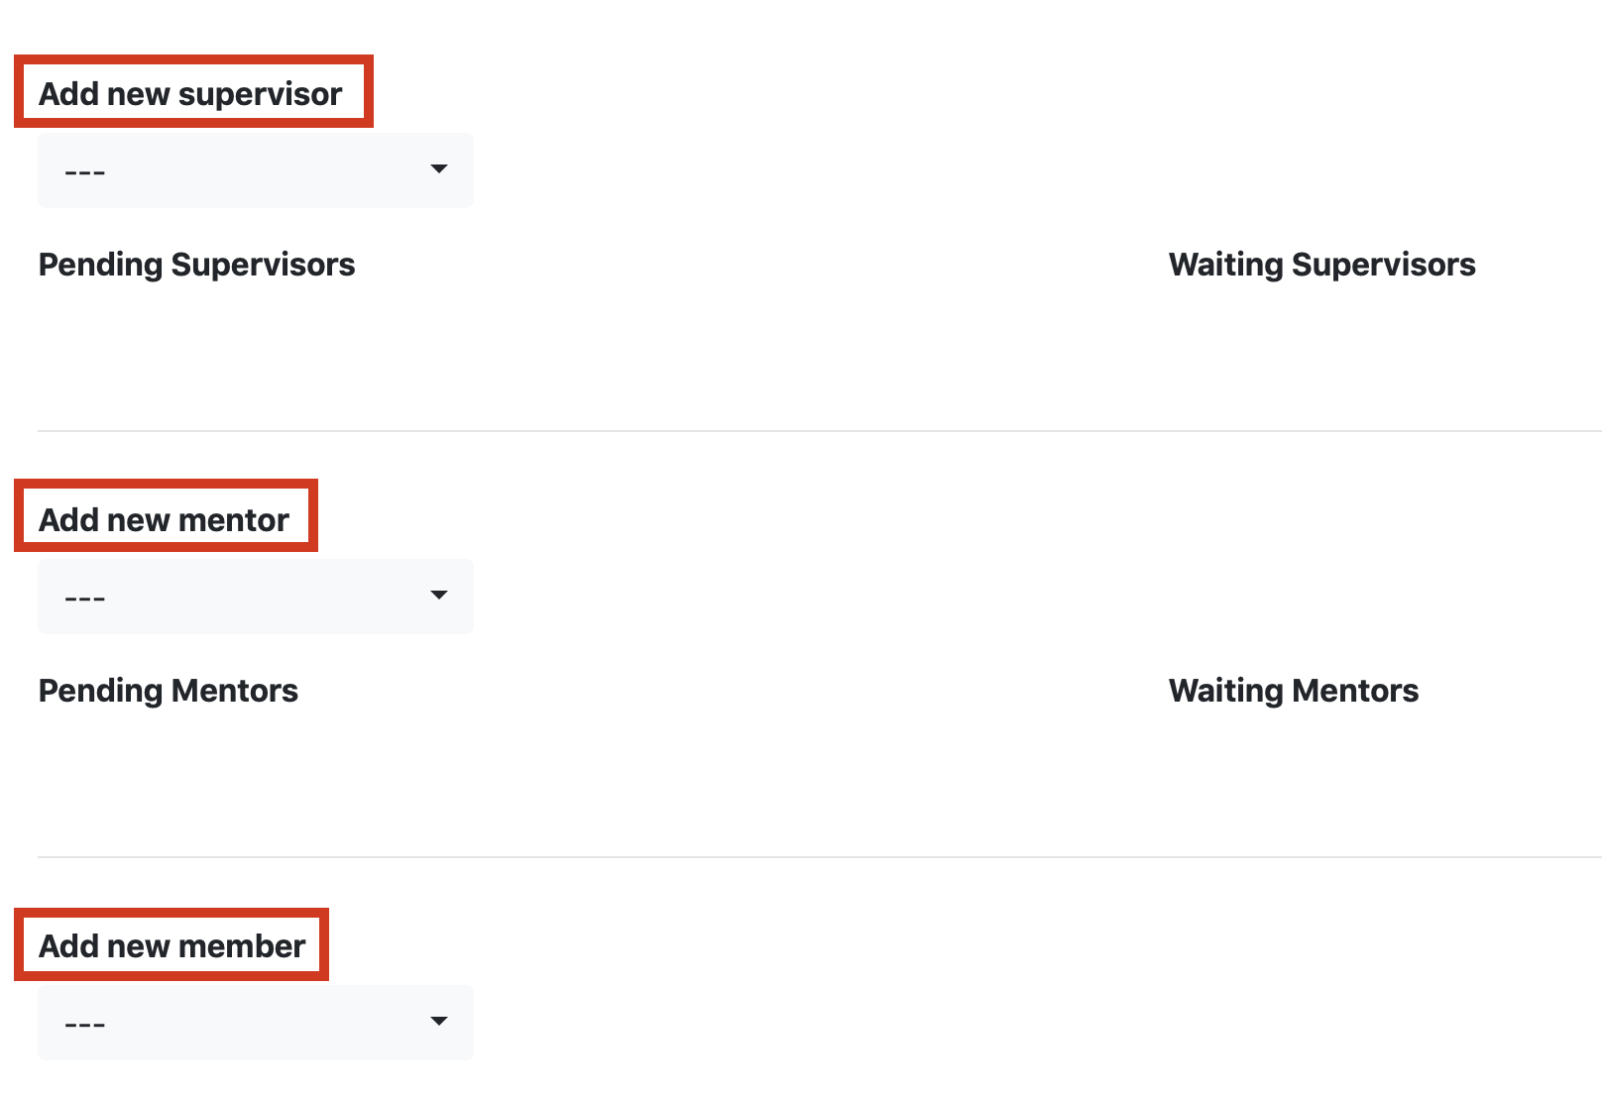

Once the team is complete that the members sign and submit a collaborator contract. After it is approved by the main supervisor and then director team, the project is started, and the status of the project is changed to “Ongoing”.

### **Set the meeting time, Communication link, and language**

To set attendance/absence list, the main supervisor must go to the My Projects page (Dashboard → Projects → My Projects). Thus, s/he will find a “Manage Attendance” button, as follows.

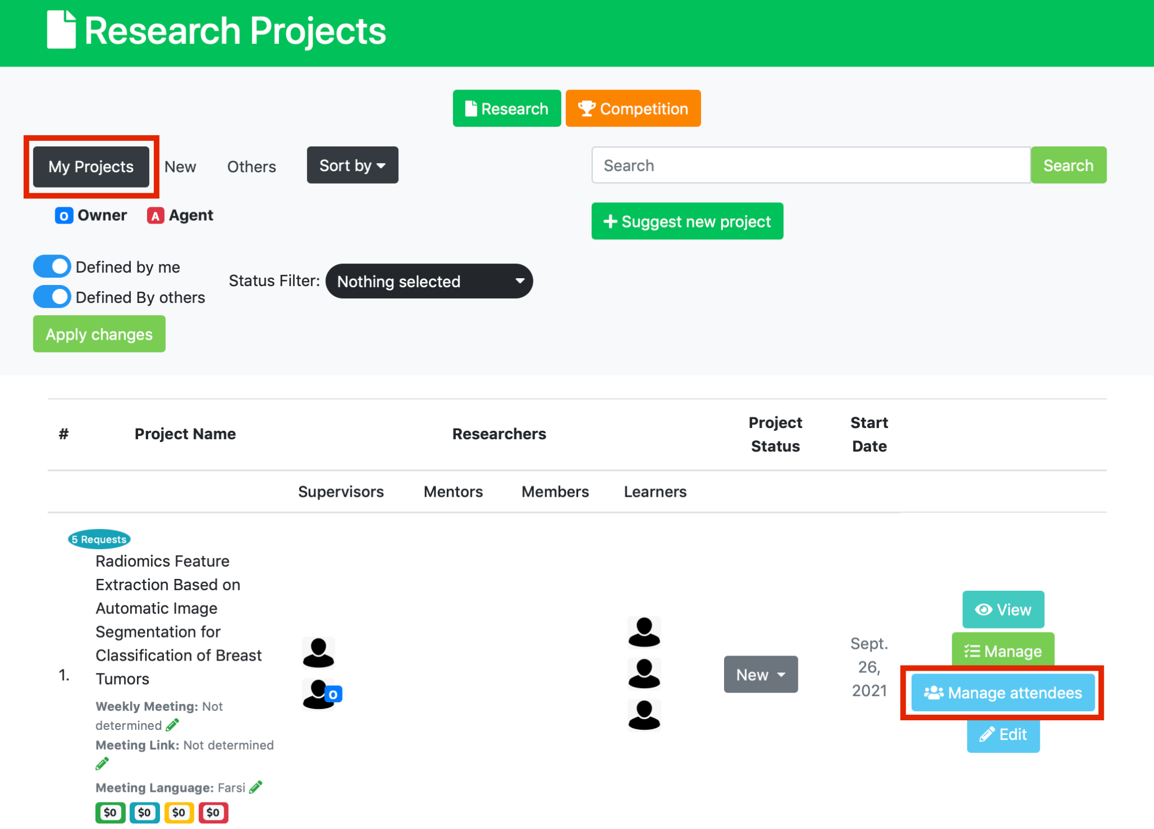

Thus, after selecting Manage Attendance button, you will enter a new page and you can add a new row and create attendance or absence action, as follows. Once you have been selected as the main supervisor for a project, you must set weekly meeting time and communication link (Zoom, Skype etc.) and put both in places considered for you in the project profile. The supervisor can even determine on what language the meeting will be run. To set three mentioned items, the supervisor can press “Change” button and then a new window will open as follows.

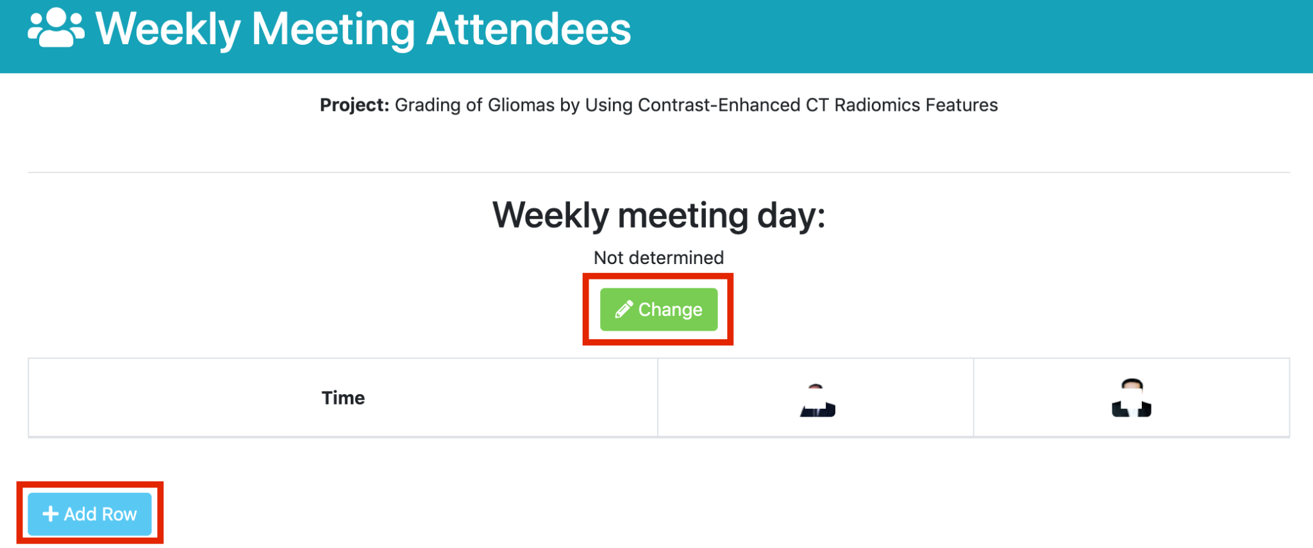

Fill in the required information including the day and time of weekly meeting, the meeting link and its language, as follows.

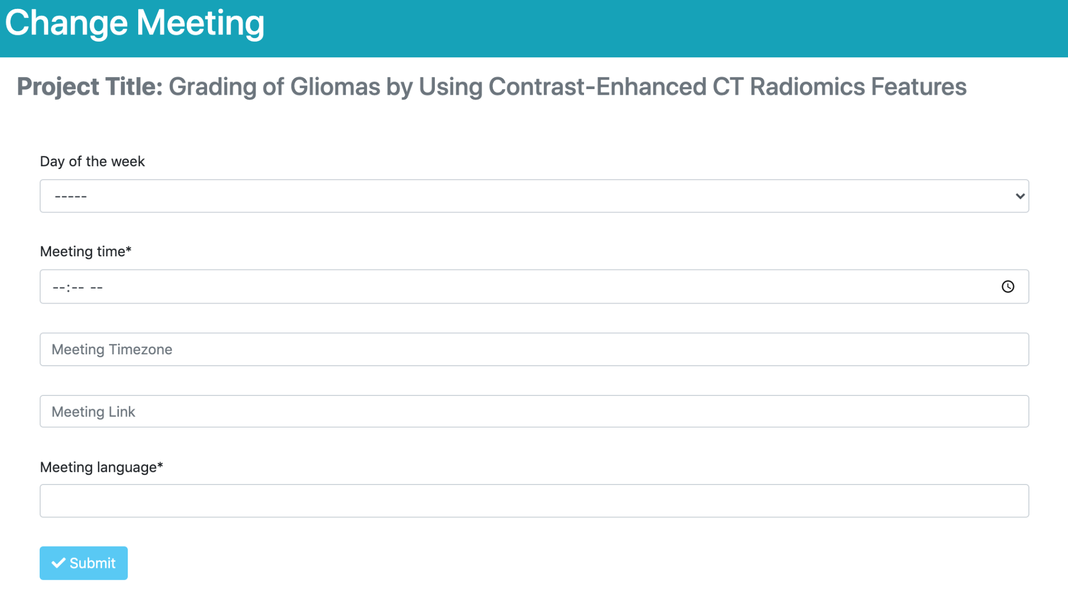

After specifying these items, the meeting information is visible under the project name and the members involved in the project can see it.

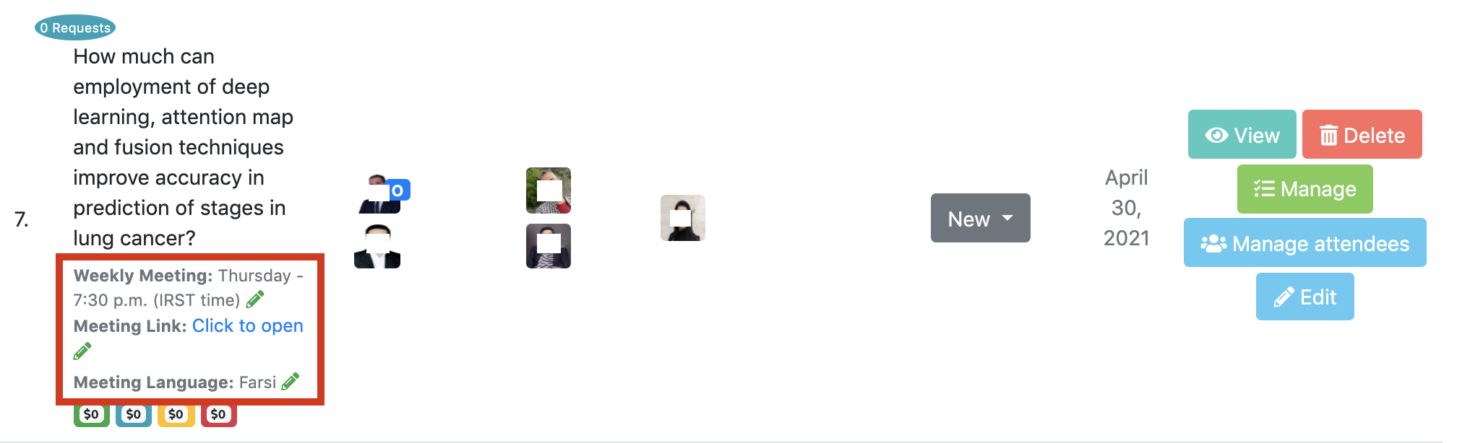

The main supervisor can also choose one member involved in the project as an agent to update these items, as follows. For this action, the main supervisor must press “Manage” button, going to project page and selecting the agent as follows.

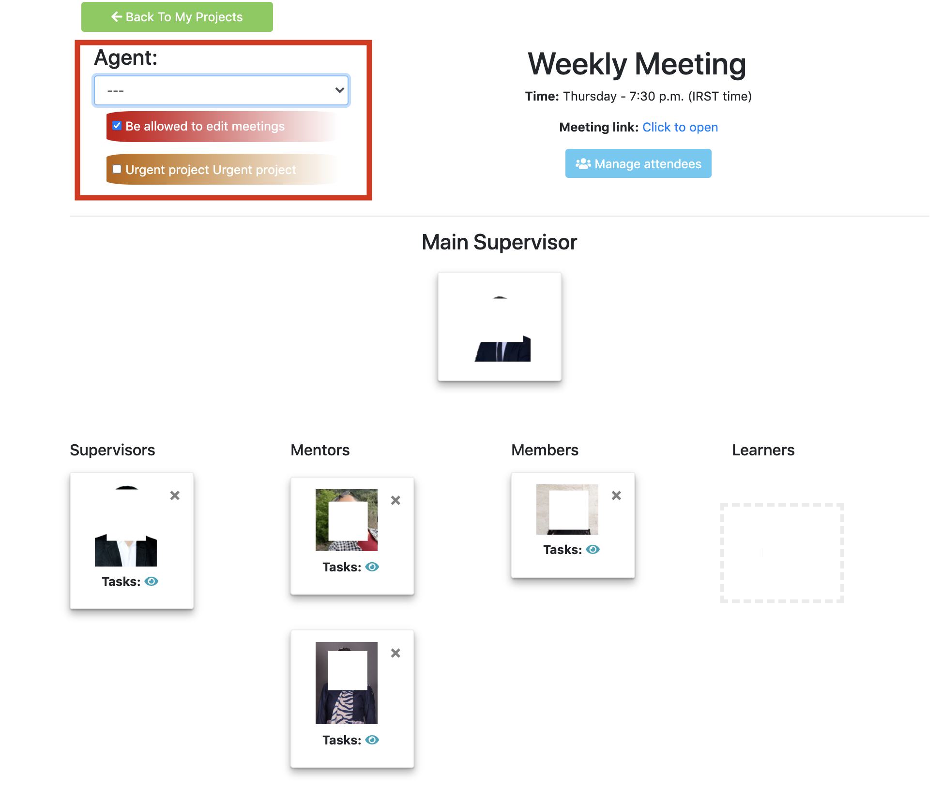

If the project urgently needs a member(Sometimes an ongoing project loses a member and needs to be replaced immediately), it gets an urgent tag and will be located at the top of the projects list, so members can see its urgency and apply for that.

### **Specify tasks for members within the project**

After starting the project, tasks of the member must be specified the main supervisor. To determine members’ tasks, go to the My Projects page (Dashboard → Projects → My Projects), then click on Manage option of that project.

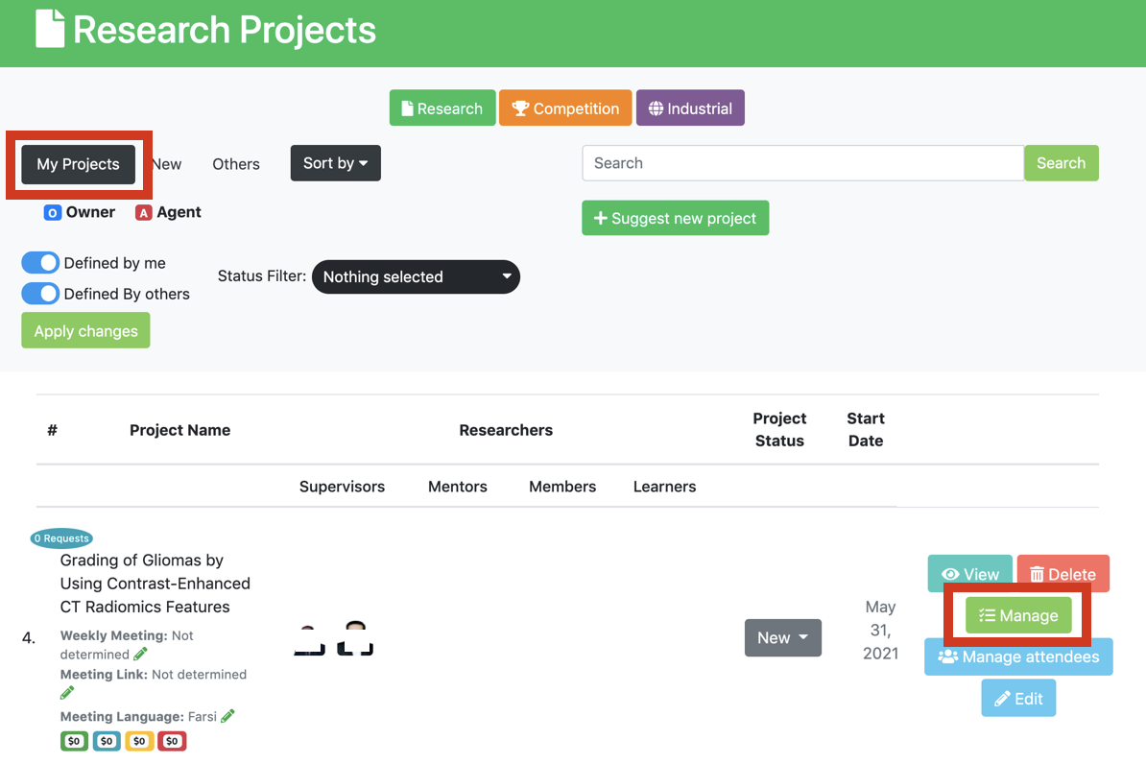

On this page, you can see an icon that looks like a pencil, as follows.

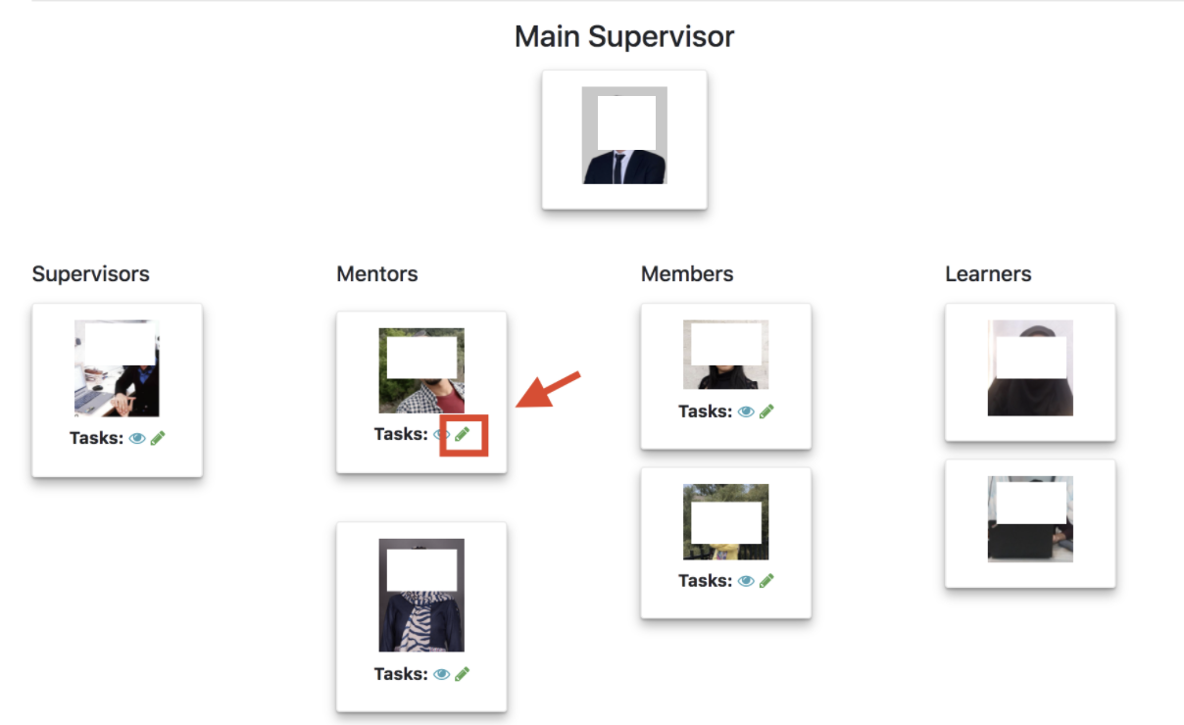

Using this option, you can reveal members’ tasks and arrange your team based on tasks, as follows.

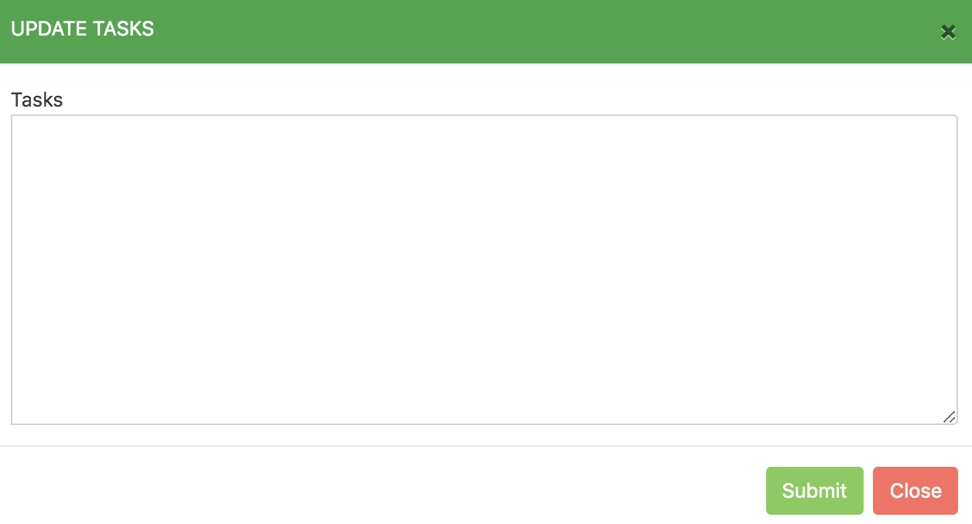

### **How can a supervisor define a new project?**

# **Go to suggest a project**

If you have an idea and want to suggest it for a project, just click on “suggest research/competition projects “and complete the form. You can find it in your Dashboard.

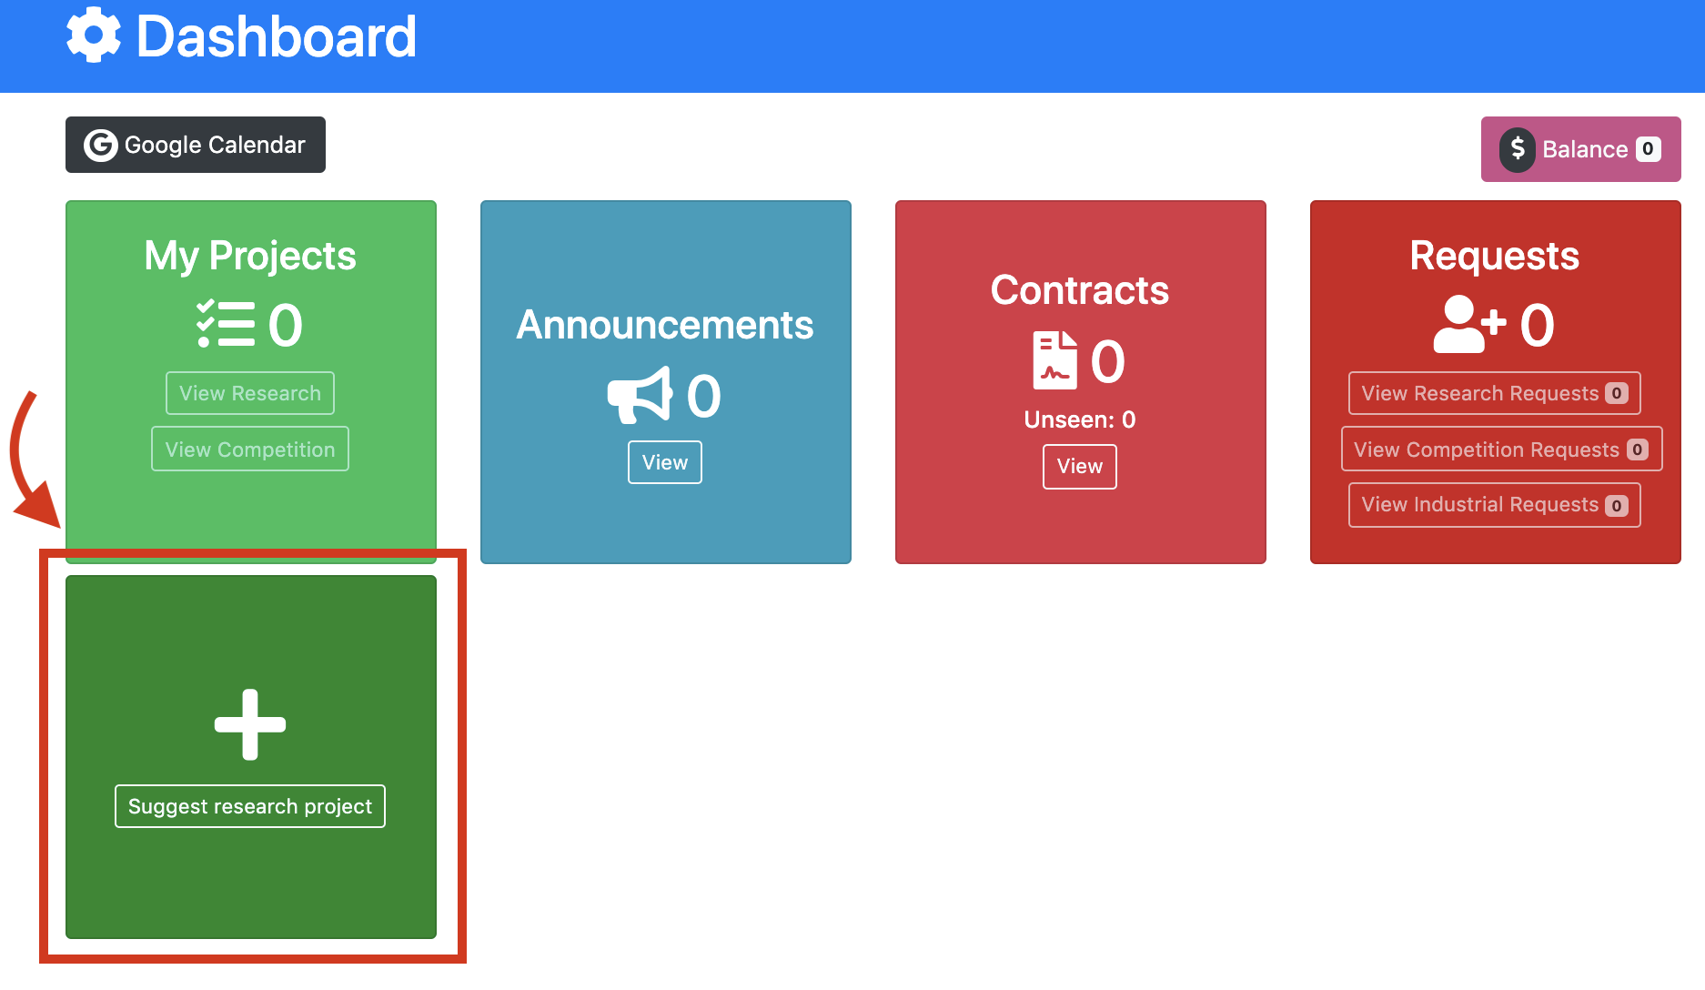

# **Fill the information**

By clicking on Suggest a new project, you will enter the following page as shown below and you must fill in the required information. These are explained in the next sections.

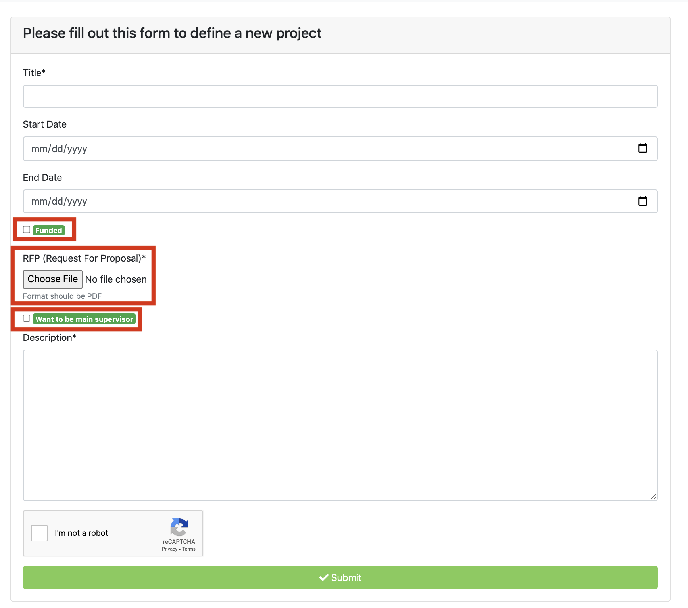

If you want to play the role of a Main Supervisor in your project, you must check the option and send a proposal for the project. After you select the Supervisor option, in addition to the “Description”, two other sections, “Project Equipment” and “Project Requirements”, will be added, which you should also write about.

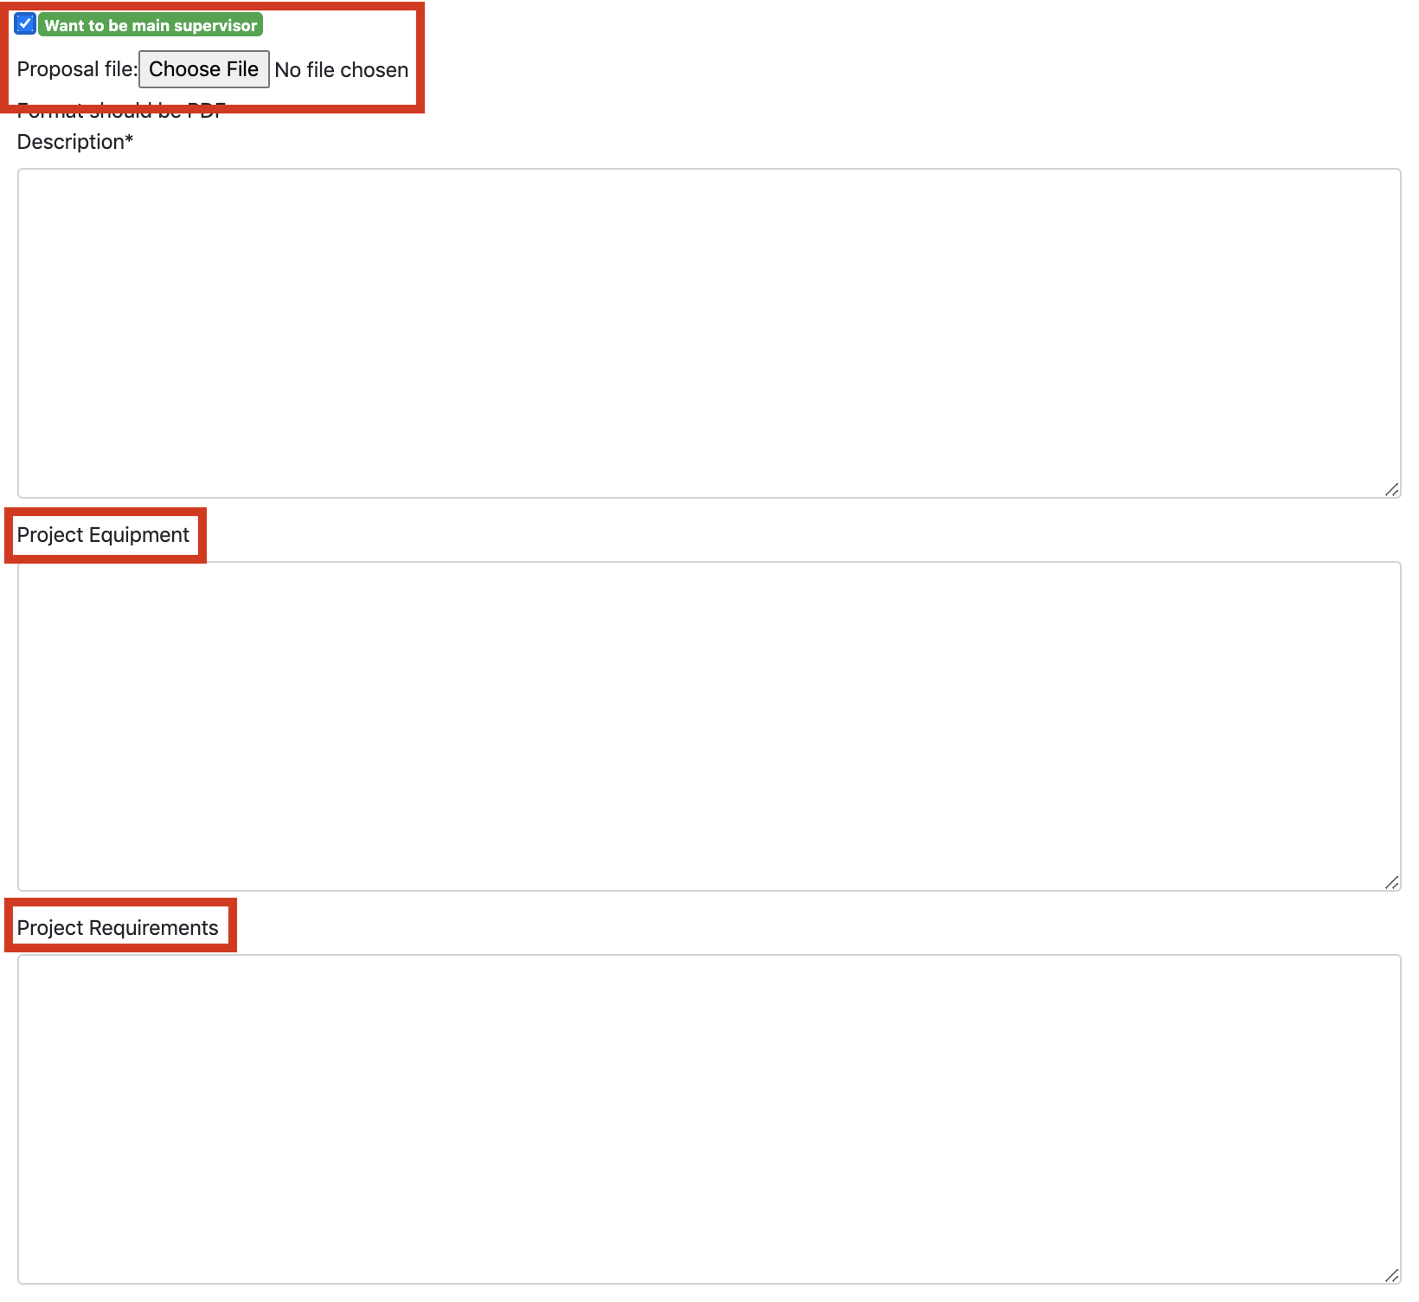

# **Increase in your credit if the project is funded**

In the previous section, there is a section called Funded. If your project has being funded, you must check this box and enter amount of fund. We recommend the supervisors should first increase in the balance and then use this amount to fund the project.

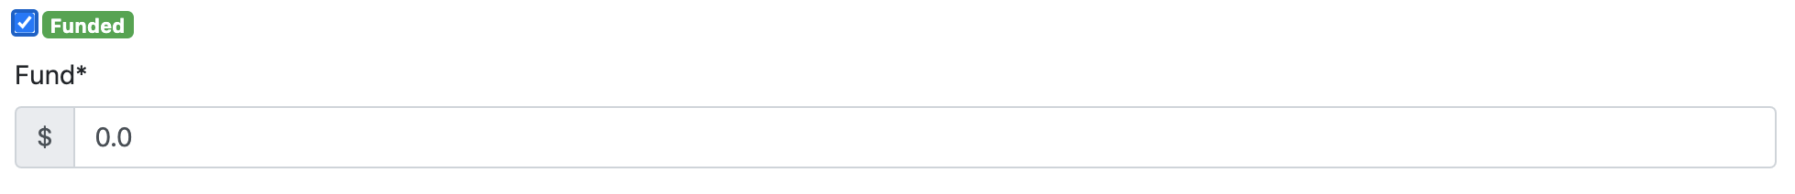

If the amount of your desired fund is less than your account balance, it will give you the following notification, which means that in order to submit the form, you must increase in your balance up to the amount of the fund. You can charge your account by going to checkout.

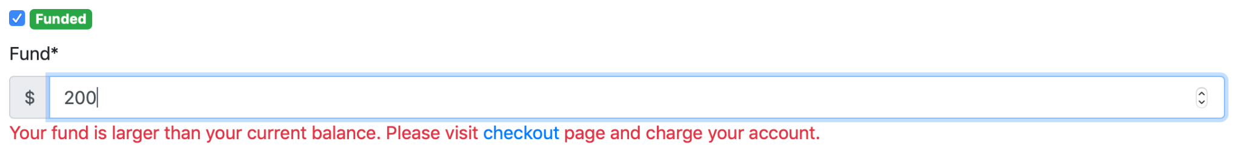

# **d. Send an RFP, Proposal**

For RFP, you must specify Description, Project Requirements, and Project Equipment. Your file format should be PDF and you must upload in the following section:

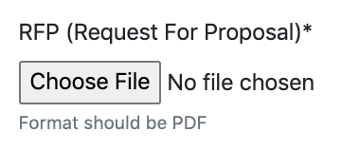

But if you want to be a main supervisor of your project, there is also a section about “Proposal File” in the form where you have to upload a proposal from the project you have defined.

As mentioned in the form, proposal file format should be as a PDF file.

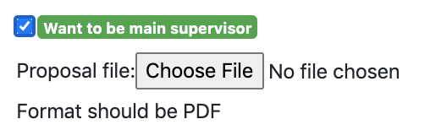

Your proposal should be as a PhD research proposal. Typically, your proposal should be included the below information:

* Title
* Overview of the project

### Positioning of the project

### Project methodology

* Plan of work & time schedule

### Bibliography

**Note:** The proposal will be rejected if there is a misspelling, so be sure to double check before submitting!

**e. Sign the contract**

If you want to be a main supervisor of your project, after accepting your project and your main supervisor roles by the company, a contract will be sent to you to start cooperation with the company.

The contract will be sent to the “Contracts” section in your Dashboard.

The below figure shows where supervisor should find the contract.



For other applicants including supervisors, mentors, members, and learners, the main supervisor will observe the contract on behalf of the company.

After clicking on View, you will enter the below page. From “View Contract”, you should open the contract and then reading, downloading as a PDF file, and signing.

In the end, you must upload the signed contract and then press Submit button as follows.



After that, you can see your submitted contract as follows.



After signing the contract and confirming it by the Research Director, you can form your team (As described in the previous sections). Then you can introduce your team to TECVICO. The project will be started with the approval of the contract of the member involved in the project.

**Note**: If your defined project has been accepted by TECVICO and you would not like to be the main supervisor on this project, the company will select the Main Supervisor and her/his team to accomplish the project. If you agree, you must sign the contract which the company will send you.

### 